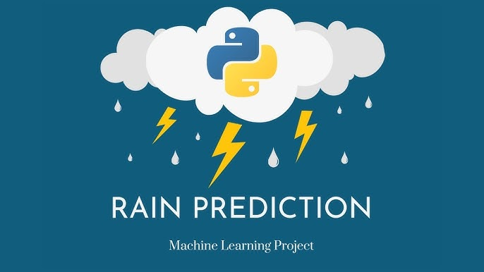

Objective :
Rainfall forecasting is an important task for water resource management, agriculture, and disaster prevention. However, rainfall is a complex phenomenon that is difficult to predict accurately. Machine learning and artificial neural networks (ANNs) have been shown to be effective tools for rainfall forecasting.

Attributes Information:
The following is a description of the attributes in the rainfall forecasting dataset:
- SUBDIVISION: The geographical subdivision of the region where the rainfall was measured.
- YEAR: The year in which the rainfall was measured.
- JAN, FEB, MAR, APR, MAY, JUN, JUL, AUG, SEP, OCT, NOV, DEC: The monthly rainfall in millimetres.
- ANNUAL: The total annual rainfall in millimetres.
- Jan-Feb, Mar-May, Jun-Sep, Oct-Dec: The rainfall in millimetres for the following three-month periods:
  - Jan-Feb: January and February
  - Mar-May: March, April, and May
  - Jun-Sep: June, July, and August
  - Oct-Dec: October, November, and December
These attributes can be used to train machine learning models to predict rainfall for future dates. For example, a model could be trained to predict the monthly rainfall in a given subdivision for the next month, given the historical rainfall data for that subdivision and the rainfall data for other subdivisions in the region.
The dataset can also be used to analyse rainfall patterns over time and space. For example, researchers could use the dataset to identify trends in rainfall, such as whether rainfall is increasing or decreasing in a particular region. They could also use the dataset to identify correlations between rainfall and other factors, such as temperature or land use.
Overall, the rainfall forecasting dataset is a valuable resource for researchers and practitioners who are interested in understanding and predicting rainfall
Null values treatments:
We find the data set contain null_values in it it contain the null values null null are high we remove the whole null values inside of treating values
In these data set we have an attribute with high no.of null values we remove null in the attribute
Exploratory data analysis:
We can perform univariate ,bivarient ,multivariate analysis
Univariate analysis : we can draw hist plot for each and every attribute
Bivariate analysis: we can draw plot for the year and annual rainfall form these we find that 1950 has highest rainfall compare to all years In another plot we can label each and every month for the year and rainfall
Multivariate analysis:From these we can draw the heatmap for the multi varient analysis in these we can find the correlation between each and every attributes
Machine learning Algorithms:
Linear regression:
A linear model is a machine learning algorithm that assumes that the relationship between the input features and the target variable is linear. This means that the predicted value is a weighted sum of the input features, where the weights are learned from the training data.
Linear models are one of the simplest and most popular machine learning algorithms. They are easy to understand and implement, and they can be used to solve a wide variety of problems, including regression, classification, and anomaly detection.
Linear models are often used as a baseline model in machine learning experiments. This is because they are easy to train and evaluate, and they can provide a good starting point for comparing the performance of more complex algorithms.
Linear models have several advantages:
- They are easy to understand and implement.
- They can be used to solve a wide variety of problems.
- They are computationally efficient.
- They are interpretable.
However, linear models also have some disadvantages:
- They may not be as accurate as more complex algorithms, such as neural networks.
- They may not be able to capture complex relationships between the input features and the target variable.
Overall, linear models are a powerful and versatile tool for machine learning. They are a good choice for many problems, especially those where simplicity and interpretability are important.
Support vector regression:
Support vector regression (SVR) is a machine learning algorithm for regression tasks, which involve predicting a continuous value from a set of input features. SVR is based on the support vector machine (SVM) algorithm, which is a supervised learning algorithm for classification tasks.
SVR works by finding a hyperplane in the input space that separates the data points into two groups, with the target variable on one side of the hyperplane and the non-target variable on the other side. The predicted value for a new data point is then calculated as the distance between the data point and the hyperplane.
SVR is a more flexible algorithm than linear models, as it does not make any assumptions about the relationship between the input features and the target variable. This means that SVR can be used to model complex relationships, even if they are nonlinear.
SVR is also a more robust algorithm than linear models, as it is less sensitive to outliers and noise in the data.
Here is a summary of the advantages and disadvantages of using SVR for regression tasks:

Advantages:
- Flexible: Can model complex, nonlinear relationships between the input features and the target variable.
- Robust: Less sensitive to outliers and noise in the data.
- Generalizable: Can perform well on new data that has not been seen before.
Disadvantages:
- Computationally complex: Training and predicting with SVR can be computationally expensive, especially for large datasets.
- Less interpretable: SVR models can be more difficult to interpret than linear models.
Decision Tree :
Decision tree algorithm is a supervised machine learning algorithm that can be used for both classification and regression tasks. It is a tree structure consisting of a root node, internal nodes, and leaf nodes. The root node represents the input features, the internal nodes represent the decision rules, and the leaf nodes represent the predictions.
The decision tree algorithm works by recursively splitting the data into subsets based on the most significant feature at each node of the tree. The splitting process stops when the data at a node is pure, meaning that it all belongs to the same class or has the same value.
To make a prediction, a decision tree algorithm works its way down the tree from the root node. At each internal node, it compares the value of the input feature to a threshold value. If the value is above the threshold, the algorithm follows the branch to the right child node. Otherwise, it follows the branch to the left child node. The algorithm continues until it reaches a leaf node, which is the prediction.
Decision tree algorithms are easy to understand and interpret. They can be used to solve a wide variety of problems, including:
- Classification problems: Predicting the class of a new data point, such as whether an email is spam or not spam, or whether a customer will churn or not churn.
- Regression problems: Predicting the value of a continuous variable, such as the price of a house or the number of customers who will visit a store on a given day.
Here are some key points about the decision tree algorithm:
It is a supervised learning algorithm, meaning that it needs to be trained on a labelled dataset before it can make predictions.
- It can be used for both classification and regression tasks.
- It is easy to understand and interpret.
- It can be used to solve a wide variety of problems.
- It can be overfitting, so it is important to use regularisation techniques such as pruning.
Overall, the decision tree algorithm is a powerful and versatile machine learning algorithm that can be used to solve a wide variety of problems.
RandomForest algorithm:
Random forest is an ensemble learning method for classification, regression and other tasks that operates by constructing a multitude of decision trees at training time and outputting the class that is the mode of the classes (classification) or mean prediction (regression) of the individual trees.
Random forests are a powerful machine learning algorithm that can be used for both classification and regression tasks. They are easy to understand and interpret, and they can be used to solve a wide variety of problems.
Here are some key points about the random forest algorithm:
- It is an ensemble learning algorithm, meaning that it combines the predictions of multiple learners to make a final prediction.
- It is based on the decision tree algorithm.
- It introduces two sources of randomness into the training process:
  - Bootstrap aggregation (bagging): Each tree in the forest is trained on a random sample of the training data, with replacement. This means that some data points may be included in multiple trees, while others may not be included in any trees.
  - Feature randomness: At each split in the tree, a random subset of features is considered. This helps to prevent the trees from overfitting to the training data.
- Random forests are very resistant to overfitting.
- They can be used to solve a wide variety of problems, including:
  - Classification problems: Predicting the class of a new data point, such as whether an email is spam or not spam, or whether a customer will churn or not churn.
  - Regression problems: Predicting the value of a continuous variable, such as the price of a house or the number of customers who will visit a store on a given day.
Overall, the random forest algorithm is a powerful and versatile machine learning algorithm that can be used to solve a wide variety of problems. It is easy to understand and interpret, and it is very resistant to overfitting.
Here are some additional benefits of using random forests:
- They are relatively fast to train and predict.
- They can handle high-dimensional data.
- They are relatively insensitive to outliers.
- They can be used to generate feature importances, which can help to identify the most important features in the data.
Random forests are a popular choice for machine learning problems, and they are widely used in a variety of industries, including finance, healthcare, and marketing.
Artificial neural network:
Artificial neural networks (ANNs) are a type of machine learning algorithm that are inspired by the structure and function of the human brain. ANNs are made up of interconnected nodes, called neurons, which process information and send signals to other neurons.
ANNs can be trained to perform a wide variety of tasks, including regression, classification, and anomaly detection. They are particularly well-suited for tasks that involve complex patterns in the data.
ANNs are trained by feeding them a set of labelled data. The ANN learns to associate the input features with the output labels by adjusting the weights of the connections between the neurons.
Once trained, an ANN can be used to make predictions on new data. To do this, the ANN simply processes the input features and outputs a prediction.
ANNs have several advantages over other machine learning algorithms:
- They are very flexible and can be used to solve a wide variety of problems.
- They are able to learn complex patterns in the data.
- They are often able to achieve higher accuracy than other algorithms on complex problems.
However, ANNs also have some disadvantages:
- They can be computationally expensive to train.
- They can be difficult to interpret.
- They can be overfitting, meaning that they can learn the training data too well and not generalise well to new data.
Overall, ANNs are a powerful and flexible tool for machine learning. They are a good choice for problems where accuracy and performance are important, even if the data is complex or noisy.
Here are some examples of problems that can be solved with ANNs:
- Image recognition
- Natural language processing
- Machine translation
- Speech recognition
- Medical diagnosis
- Fraud detection
If you are considering using ANNs for a machine learning task, it is important to keep in mind the computational cost of training and predicting with ANNs. It is also important to consider the interpretability of ANN models, and whether this is important for your application.
Additionally, it is important to take steps to prevent overfitting when training ANNs. This can be done by using techniques such as regularisation and cross-validation.
Hardware requirements:
• CPU: A modern multicore processor, such as an Intel Core i5 or i7, is recommended
for training and deploying machine learning models.
• RAM: A minimum of 8GB of RAM is recommended, although more may be required
for larger datasets.
• GPU: A powerful graphics processing unit (GPU) can significantly speed up training
and inference of deep learning models. Nvidia GPUs are the most commonly used for
machine learning tasks.
• Storage: A large amount of storage is required to store and process large datasets.
Solid-state drives (SSDs) are recommended for fast access to data.
Software requirements:
• Operating System: Most machine learning frameworks are compatible with popular
operating systems such as Windows, macOS, and Linux.
• Python: Python is the most commonly used programming language for machine
learning, and most machine learning frameworks are built using Python.
• Machine Learning Frameworks: There are many machine learning frameworks
available, such as TensorFlow, PyTorch, Keras, and scikit-learn. These frameworks
provide tools and APIs for building, training, and deploying machine learning
models.
• Development Tools: IDEs such as PyCharm, Jupyter Notebook, and Visual Studio
Code are commonly used for machine learning development.
• Libraries: Libraries such as NumPy, Pandas, and Matplotlib,tensorflow ,keras are commonly used for data manipulation, analysis, and visualisation, and artificial neural network
In summary, to get started with your project, you will need a computer with a powerful CPU
and GPU, a minimum of 8GB of RAM, and large storage capacity. You will also need to
install Python and various machine learning libraries and frameworks.
Existing System:
Existing rainfall forecasting systems typically rely on statistical models or numerical weather prediction models. Statistical models are trained on historical data to identify patterns in rainfall. Numerical weather prediction models solve complex physical equations to simulate the atmosphere.
However, both statistical models and numerical weather prediction models have limitations. Statistical models can be inaccurate if the patterns in historical data change. Numerical weather prediction models are computationally expensive and can be inaccurate for short-term forecasts.
Proposed System:
The proposed rainfall forecasting system uses a machine learning algorithm called an artificial neural network (ANN). ANNs are inspired by the structure and function of the human brain. They are able to learn complex relationships from data and make predictions.
The proposed system will use the following data points as inputs:
- SUBDIVISION
- YEAR
- JAN
- FEB
- MAR
- APR
- MAY
- JUN
- JUL
- AUG
- SEP
- OCT
- NOV
- DEC
- ANNUAL
- Jan-Feb
- Mar-May
- Jun-Sep
- Oct-Dec
The ANN will be trained on historical rainfall data to learn the relationships between these inputs and rainfall. Once trained, the ANN will be able to predict rainfall for future dates.
Architectural diagram:
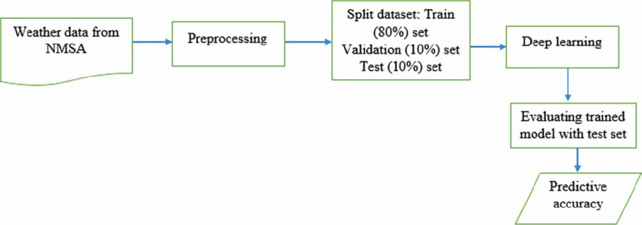

Conclusion :
Machine learning and CNNs have the potential to revolutionise rainfall prediction. By developing new models and using more data, researchers can improve the accuracy and reliability of rainfall predictions. This could have a significant impact on a wide range of sectors, including agriculture, water resource management, and disaster prevention.
Here are some of the key benefits of using machine learning and CNNs for rainfall prediction:
- Accuracy: Machine learning models can be trained to achieve high accuracy in rainfall prediction, even for complex and noisy data.
- Robustness: Machine learning models can be robust to outliers and noise in the data. This is important for rainfall prediction, as rainfall data can be noisy and incomplete.
- Interpretability: CNNs are relatively interpretable machine learning models. This means that it is possible to understand how the model makes predictions. This is important for rainfall prediction, as it allows users to better understand the limitations of the model and make more informed decisions.
While there are many potential benefits to using machine learning and CNNs for rainfall prediction, there are also some challenges that need to be addressed. One challenge is the need for large amounts of training data. Machine learning models require large amounts of data to train effectively. This can be a challenge for rainfall prediction, as it is difficult to collect and clean large amounts of rainfall data.
Another challenge is the need for computational resources. Training and deploying machine learning models can be computationally expensive. This can be a challenge for resource-constrained organisations.
Despite the challenges, the future of rainfall prediction using machine learning and CNNs is very promising. By developing new models and using more data, researchers can improve the accuracy and reliability of rainfall predictions. This could have a significant impact on a wide range of sectors, including agriculture, water resource management, and disaster prevention.

